**Recyclable Item Detection Model Using Machine Learning**

ABSTRACT

Waste management and recycling is the fundamental part of the sustainable development. Most of the people are not aware of the correct methods for disposing the waste products, especially in major cities it has become a crucial issue. The importance of recycling is well known for the betterment of our environment. In order to achieve the goal of sustainability one must know the difference between the recyclable and non-recyclable materials. We have taken an initiative to build a machine learning model which will identify the items and classify them into recyclable and non-recyclable products. In order to create a distinctive dataset, images were collected via various sources. The model has been trained using the Convolutional Neural Network to achieve the best accuracy. The model ensures the recycling of the quality materials and limits the harm that can be done downstream from poorly sorted, problematic or contaminated materials.

1. INTRODUCTION

Recycling of solid waste is a big challenge around the world. Human activities result in a lot of solid waste, without sorting solid-waste there is a negative impact on the environment. Recycling of solid waste problem in developing countries, such as India, has a number of aspects related to them, such as technological, official, financial, environmental and communal aspects.

When people are throwing away something seemingly useless, they are often in doubt: Is this recyclable or not? Recyclable items are valuable material rather than trash. By reusing recyclable items, a huge amount of energy cost to manufacture new materials and to deal with waste can be saved to help sustain a greener living environment for us all. Many kinds of glass, paper, metal, plastic, textiles, and electronics are recyclable materials, and should not be put into trash bins where non-recyclable materials should stay. But can people memorize all that recycling knowledge? No. However, with the help of a specific software, images of items that will be thrown away can be processed by computer vision and classified by supervised machine learning methods, thus intelligently tell users the recyclability of their items without pain.

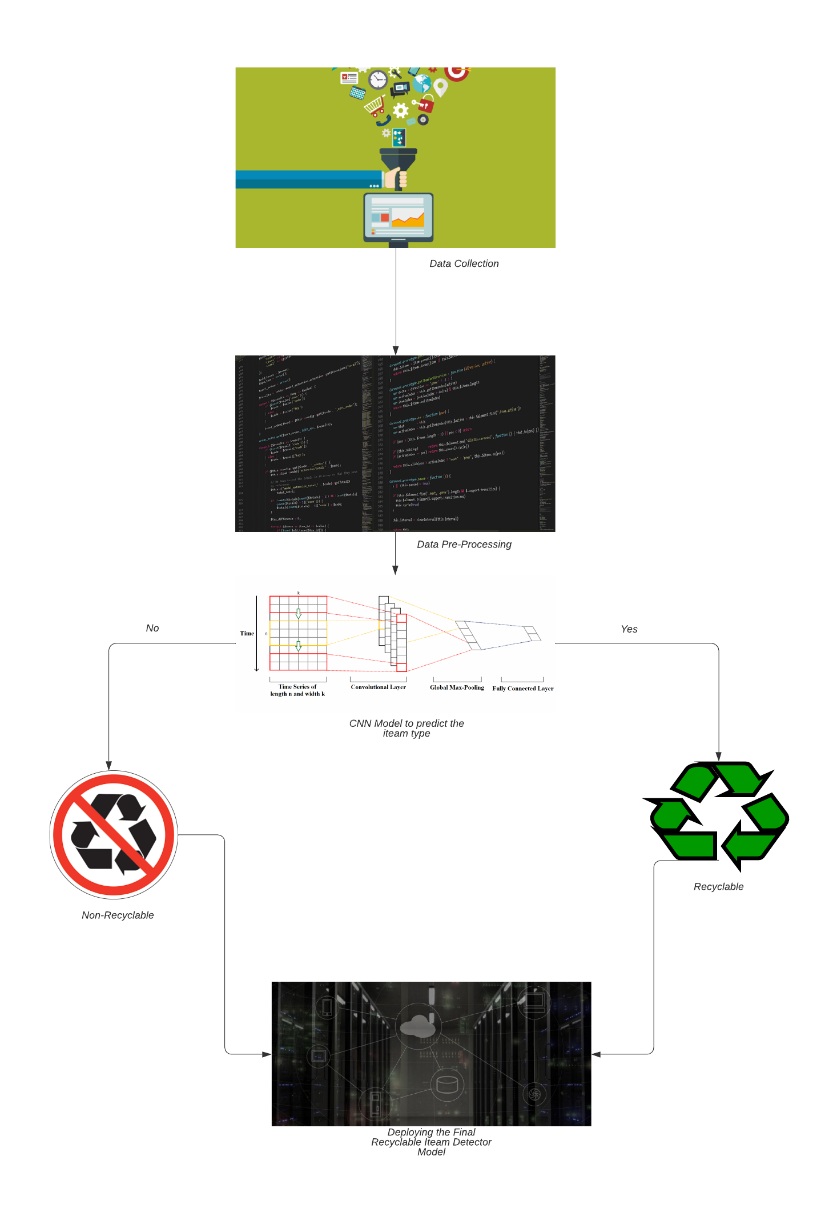

Fig 1:- Generic Flowchart

1. RELATED WORK

In this project [5], with the development of technology, Artificial Intelligence (AI) [6] becomes popular and people make use of it to do jobs. But for recyclable materials selection, most of the classification jobs are still done manually. Therefore, this project is aimed to developed a system for classifying materials by using Machine Learning[7]. This paper introduces Tensor Flow which is an open source for Machine Learning. By using it, single object is able to be recognized but not for multiple objects in one image. Because of this limitation on tensor Flow, the idea on the combination of Machine Learning and Open Source Computer Vision Library (Open CV) [8] image processing is also illustrated in this paper. As a result, most of the materials can be recognized and highlighted in an image.

In this project [9], the aim of this research is to improve municipal trash collection using image processing algorithms and deep learning technologies for detecting trash in public spaces. This research will help to improve trash management systems and create a smart city. Two Convolutional Neural Networks (CNN), both based on the AlexNet network architecture, were developed to search for trash objects in an image and separate recyclable items from the landfill trash objects, respectively. The two-stage CNN system was first trained and tested on the benchmark Trash Net indoor image dataset and achieved great performance to prove the concept. Then the system was trained and tested on outdoor images taken by the authors in the intended usage environment. Using the outdoor image dataset, the first CNN achieved a preliminary 93.6% accuracy to identify trash and non-trash items on an image database of assorted trash items. A second CNN was then trained to distinguish trash that will go to a landfill from the recyclable items with an accuracy ranging from 89.7% to 93.4% and overall, 92%. A future goal is to integrate this image processing-based trash identification system in a smart trashcan robot with a camera to take real-time photos that can detect and collect the trash all around it. [2]

1. **RESEARCH METHODOLOGY**

In this section, the various steps to achieve a recyclable item detection model have been discussed. A new dataset of all the non-recyclable and recyclable items have been made which consists of images of batteries, cardboard, glass etc. After which it is trained on Convolution Neural Network.

1. **Preparation of Dataset**

There are no public datasets of images appropriate for deciding the recyclability of an item. Collection hundreds of images to build a dataset has been done. An image in the dataset contains one item, either recyclable or non-recyclable, and is properly labelled. Dataset will be enforced the following restrictions to improve the accuracy of identification. Image is a clear white blank background to ensure the item does not confuse with irrelevant objects. Item must be entirely contained within the image.

1. **CNN**

The dataset has been trained with the help of machine learning algorithm i.e. CNN. The accuracy of approximately 82% has been noted so far. To increase the accuracy of the project we will be adding more images to train our model in the dataset.

1. **PROPOSED METHODOLOGY**

With the help of object detection the non-recyclable and recyclable items were segregated. This would make it easier to reduce the harmful effects that these waste-material do to our nature.

This model then further is embedded into electronic-sensor systems. With the help of these sensors the dust-bin lid will open if the object is rightly detected by the sensor.

1. **FUTURE WORK**

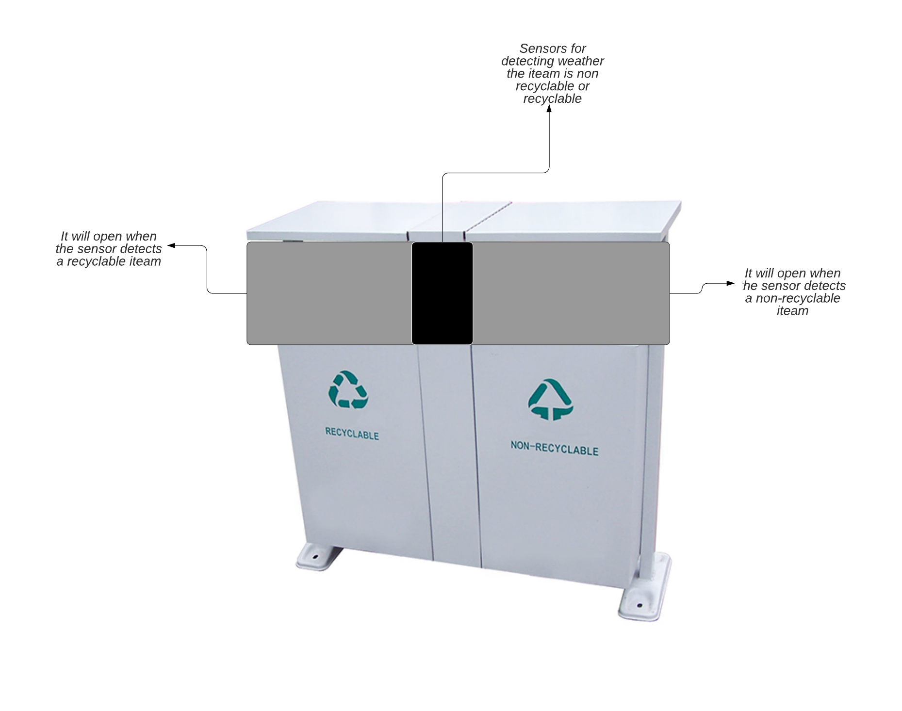

**RESULT AND CONCLUSION**

The final model is made with would detect weather an object is recyclable or not. This can be put in use for smart bins model which is mentioned in the part of future work.

References